H.T No
Regulations:
A20

Sreenidhi Institute of Science and Technology
(An Autonomous Institution)
Code No:8B411 Date: 27-Jan-2025 (AN)

B.Tech II-Year II- Semester External Examination, January-2025 (Supplementary)
FLUID MECHANICS AND HYDRAULIC MACHINERY (MECHANICAL)

Time: 3 Hours Max.Marks:70

Note: a) No additional answer sheets will be provided.
b) All sub-parts of a question must be answered at one place only, otherwise it will not be valued.
c) Missing data can be assumed suitably.

Bloom's Cognitive Levels of Learning (BCLL)

Remember | L1 | Apply | L3 | Evaluate | L5
Understand | L2 | Analyze | L4 | Create | L6

Part - A Max.Marks:20
Answer all QUESTIONS

 |  | BCLL | CO(s) | Marks
1 | Define kinematic viscosity | L3 | CO1 | [2M]
2 | State Bernoulli’s theorem | L2 | CO2 | [2M]
3 | Write down the Darcy Weisbach formula | L4 | CO3 | [2M]
4 | What is dynamic similarity | L3 | CO4 | [2M]
5 | What is priming of a centrifugal pump | L3 | CO5 | [2M]
6 | Define Hydraulic efficiency define mechanical efficiency of turbines | L3 | CO6 | [2M]
7 | Define capillarity | L4 | CO1 | [2M]
8 | According to Reynolds number when do you say a flow is a laminar flow or a turbulent flow. | L2 | CO4 | [2M]
9 | What is an indicator diagram of reciprocating pump | L3 | CO5 | [2M]
10 | Define unit power | L4 | CO6 | [2M]
Part – B Max.Marks:50
ANSWER ANY FIVE QUESTIONS. EACH QUESTION CARRIES 10 MARKS.

 |  |  | BCLL | CO(s) | Marks
11. | a) | If the velocity distribution over a plate is given by u=2/3y-y2 in which u is the velocity in metre per second at a distance y meter above the plate. Determine the shear stress at y=0 and y=0.15m. Take dynamic viscosity of fluid as 8.63 poises. | L3 | CO1 | [5M]
 | b) | State and prove hydrostatic law | L3 | CO1 | [5M]
12. | a) | Describe the different type of flow in fluid kinematics. | L3 | CO2 | [5M]
 | b) | A 30 cm diameter pipe conveying water, branches into two pipes of diameter 20 cm and 15 cm respectively. If the average velocity in the 30 cm diameter pipe is 2.5 m/sec, find the discharge in this pipe. Also determine the velocity in 15 cm pipe if the average velocity in 20 cm diameter pipe is 2 m/sec. | L3 | CO2 | [5M]
13. | a) | The rate of flow of water through a horizontal pipe is 0.25m3/s. The diameter of the pipe which is 200 mm is suddenly enlarged to 400 mm. The pressure intensity in the smaller pipe is 11.772 N/cm2.Determine: Loss of head due to sudden enlargement | L4 | CO3 | [5M]
 | b) | Discuss about Reynolds experiment. | L3 | CO3 | [5M]
14. | a) | What is dimensional analysis and what is the need? | L3 | CO4 | [5M]
 | b) | Mention any two dimensionless numbers and their applications | L3 | CO4 | [5M]
15. | a) | What is a reciprocating pump? Describe the principle and working of a reciprocating pump with a neat sketch | L4 | CO5 | [5M]
 | b) | A centrifugal pump is to discharge 0.118 m3/s at a speed of 1450 r.p.m against a head of 25 m. The impeller diameter is 250 mm, its width at outlet is 50 mm and manometric efficiency is 75%. Determine the vane angle at the outer periphery of the impeller | L3 | CO5 | [5M]
16. | a) | A pelton wheel is to be designed for the following specifications: Shaft power=11,772 KW; Head=380 metres; Speed=750 r.p.m ; overall efficiency=86%; Jet diameter is not to exceed one-sixth of the wheel diameter. Determine Wheel diameter, No of jets required Take Cv=0.985 and Speed ratio=0.45 | L4 | CO6 | [5M]
 | b) | With the help of neat diagram explain the construction and working of a radial flow reaction turbine | L3 | CO6 | [5M]
17. | a) | A differential manometer is connected at the two points A and B as shown in fig. below. At B air pressure is 9.81 N/cm2 (abs), find the absolute pressure at A.  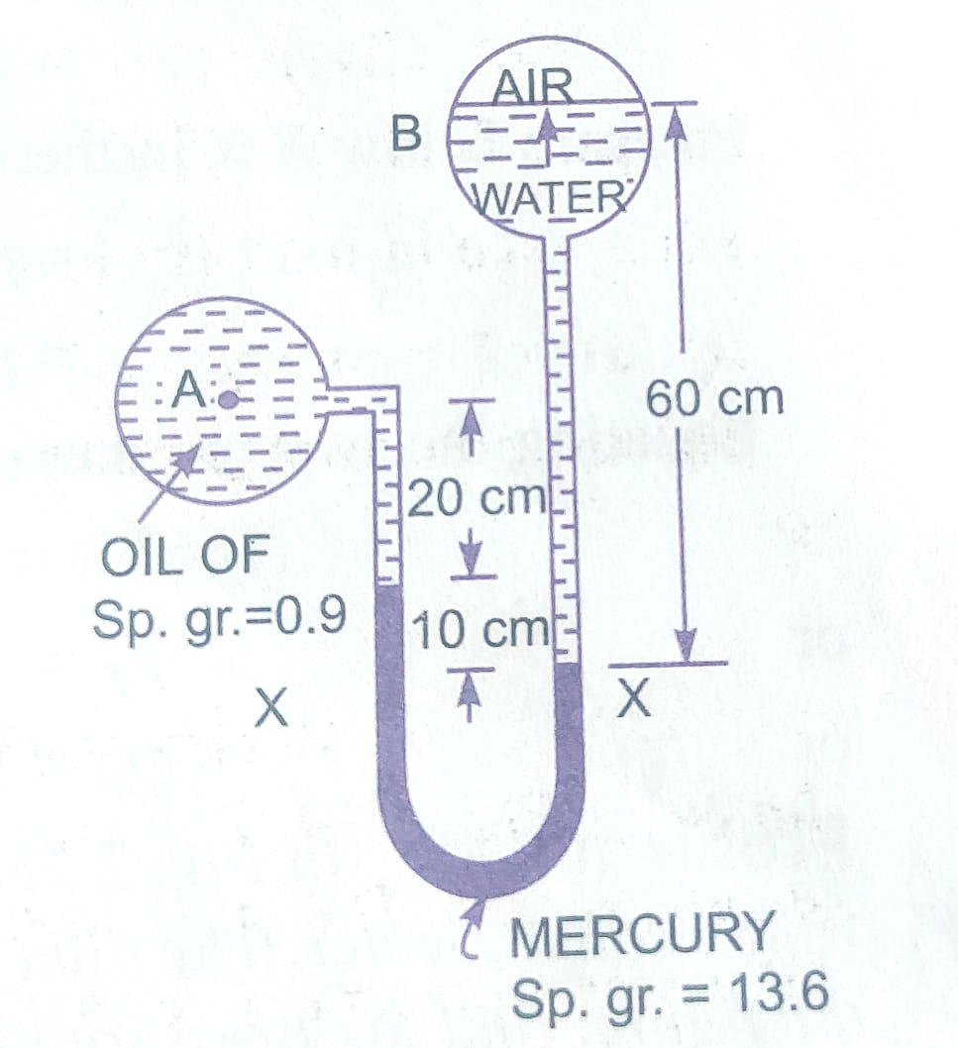 | L3 | CO1 | [4M]
 | b) | Derive the Bernoulli’s equation in case of fluid flow through a pipe | L3 | CO2 | [3M]
 | c) | Derive Darcy Weisbach equation | L3 | CO3 | [3M]
18. | a) | What are the reasons for cavitation in pumps and how do you identify it | L3 | CO4 | [4M]
 | b) | Explain the types of Multi-stage centrifugal pumps with neat sketches. | L4 | CO5 | [3M]
 | c) | Obtain an expression for the force exerted by a jet of water on a moving inclined plate in the direction of the jet. | L3 | CO6 | [3M]
-- 00 -- 00 –

